TOYO TOYS

User Guide

|  |  |  |
| --- | --- | --- |
| Supervisor. | Miss Amna |  |
| Batch. | 2301C1 |  |
| Group. | B |  |
| Serial No. | Enrollment Number | Student Name |
| 1. | 1445672 | MUHAMMAD HUZAIFA |
| 2. | 1449188 | MUHAMMAD HUNAIN |
| 3. | 1449272 | MUHAMMAD ASHAR |
| 4. | 1448244 | MUHAMMAD DANIYAL |
| 5. | 1448216 | MUHAMMAD UMAIR |

*User Guide*

1. Welcome (*0.Welcome.html*)



Used to select the language displayed on the website:

When the user selects the American flag icon, the link to the Web page displays the English language.

 When the user selects the Vietnamese flag icon, the link to the Web page displays the Vietnamese language.

|  |  |
| --- | --- |
| 2 | Layout Top |



*Fig 2: Upper Frame Interface*

2.1.1 Language Section

When clicking the Language button, the system will lead to the page to select the language. (0. Welcome.html)

2. I .2 Login Section

When you click the Sign In button, the system will display the login window.

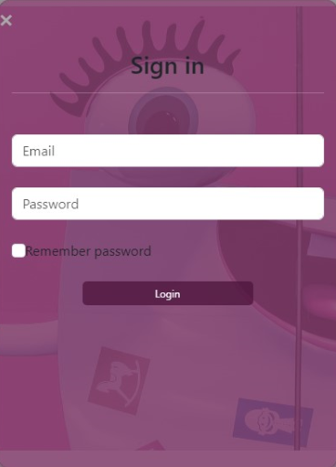

Email:

v/ Stan with a letter or number. v/ End with a letter and number.

v/ Dots, hyphens, and underscores are allowed for email names but must comply with the following requirements:

* Do not use in the start and end position.
* Its previous and next position must be a alphanumeric character.

v/ The position immediately after the @ character can be a sequence of alphabetic characters or alphanumeric characters followed by one or more phrases that staff with a dot and followed by a string of up to 4 letter characters.

Password:

Start with a letter or number.

v/ End with a letter and number.

 Limited to 10 to 20 alphanumeric characters.

2.2 Menu Bar

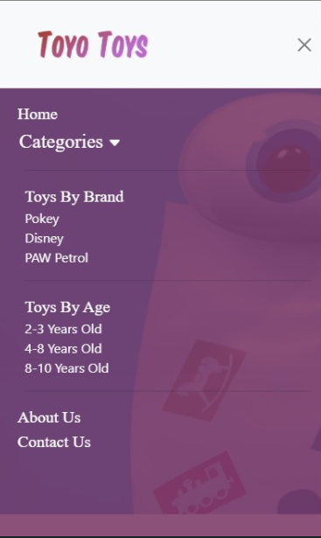

# Figure 7: Menu Bar

Used to load the remaining pages. The following is a list of those pages:

Home Page (1.lndex.html)

Products Page (2.Category.html)

 Product Line-Up 1: Toys by Brand (2.Products.html)

* Pokey (Product-Q-1 .html)
* Disney (Product-Q-2.html)
* Paw Petrol (Product-O-3 .html)

 Product Line-Up 2: Toys by Age (2.Products.html)

* 2 3year old (Product-W-1 .html)
* 4 8year old (Product-W-2-html)
* 8 10year old (Product-W-3.html)

About Us Page (3. Technology.html)

Contact Us Page (4. Support.html)

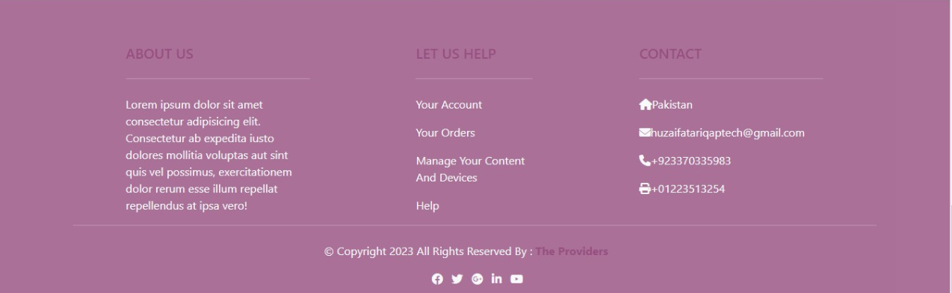

Figure 9: Layout Bottom



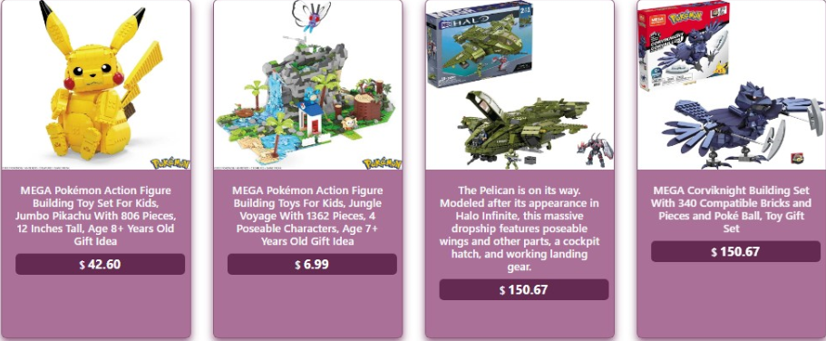

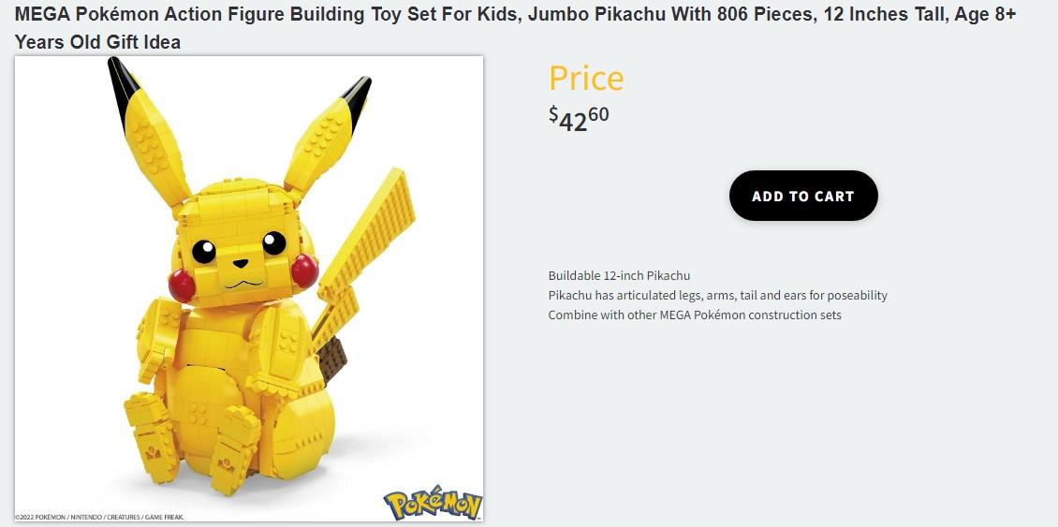



The interface of the Products page is shown as Figure: Products Page, when the user clicks on the product, the product details page will appear.

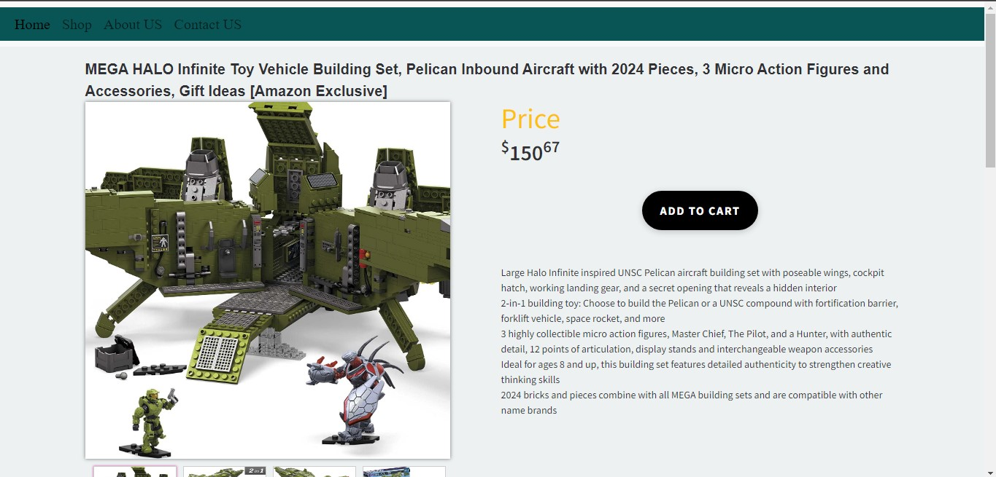

### Figure 12,' Product Line-Up

### 

### Figure 13: Add To Bag

When the user clicks the View This Product In-Store button, a container will be dropped as shown in Figure: View This Product In-Store

Thank You For Reading The Documentation.

Please Follow The Instructions Above ! !